- Calculate number of days between two dates.

from datetime import date

# sample dates
date1 = date(2014, 7, 2)
date2 = date(2014, 7, 11)

# calculate difference
diff = date2 - date1

print("Number of days:", diff.days)

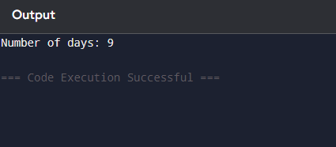

- Compute the value of n + nn + nnn

n = int(input("Enter an integer: "))
result = n + int(str(n)*2) + int(str(n)*3)
print("Value of n + nn + nnn =", result)

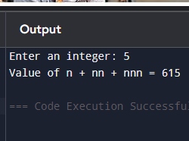

- Check whether a number is even or odd

num = int(input("Enter a number: "))

if num % 2 == 0:
print(f"{num} is even.")
else:
print(f"{num} is odd.")

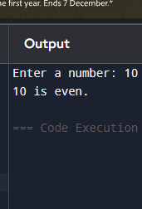

- Accept comma-separated numbers and make list & tuple

values = input("Enter comma-separated numbers: ")

list_values = values.split(',')
tuple_values = tuple(list_values)

print("List:", list_values)
print("Tuple:", tuple_values)

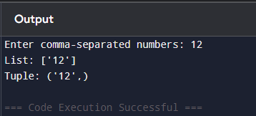

- Calculate sum of three numbers; if equal return thrice

a = int(input("Enter first number: "))
b = int(input("Enter second number: "))
c = int(input("Enter third number: "))

sum_val = a + b + c

if a == b == c:
sum_val = 3 * sum_val

print("Result:", sum_val)

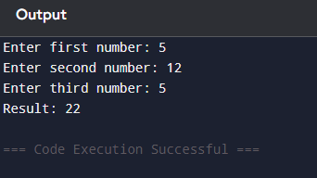

- Check whether a letter is vowel or not

ch = input("Enter a letter: ").lower()

if ch in ['a', 'e', 'i', 'o', 'u']:
print(ch, "is a vowel.")
else:
print(ch, "is not a vowel.")

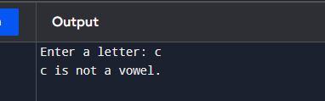

- Print elements of a list that are less than 5

a = [1, 1, 2, 3, 5, 8, 13, 21, 34, 55, 89]

for num in a:
if num < 5:
print(num)

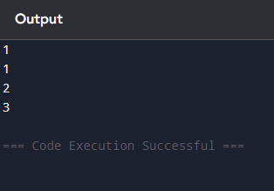

Extras:
- Create new list with elements < 5

a = [1, 1, 2, 3, 5, 8, 13, 21, 34, 55, 89]
new_list = [num for num in a if num < 5]
print(new_list)

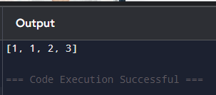

- One line version

print([num for num in [1, 1, 2, 3, 5, 8, 13, 21, 34, 55, 89] if num < 5])

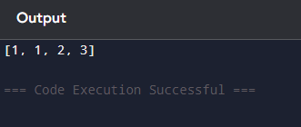

- Print all divisors of a given number

num = int(input("Enter a number: "))

print("The divisors of", num, "are:")
for i in range(1, num + 1):
if num % i == 0:
print(i)

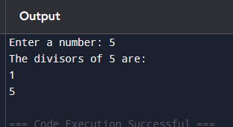

- Find common elements between two lists (no duplicates)

a = [1, 1, 2, 3, 5, 8, 13, 21, 34, 55, 89]
b = [1, 2, 3, 4, 5, 6, 7, 8, 9, 10, 11, 12, 13]

common = list(set(a) & set(b))
print("Common elements:", common)

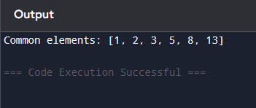

- Check if a string is palindrome or not

s = input("Enter a string: ")

if s == s[::-1]:
print("The string is a palindrome.")
else:
print("The string is not a palindrome.")

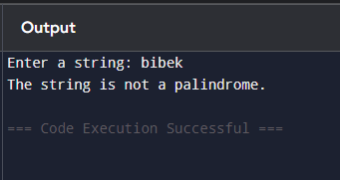

- Filter even elements from a list (one line)

a = [1, 4, 9, 16, 25, 36, 49, 64, 81, 100]
even_list = [x for x in a if x % 2 == 0]
print(even_list)

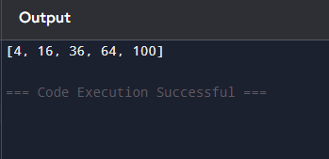

- Guess the number game

import random

number = random.randint(1, 9)
guess = int(input("Guess a number between 1 and 9: "))

if guess < number:
print("Too low!")
elif guess > number:
print("Too high!")
else:
print("Exactly right!")

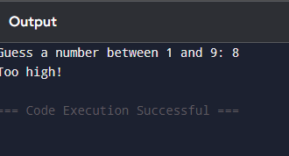

- Check whether a number is prime

num = int(input("Enter a number: "))

if num > 1:
for i in range(2, int(num ** 0.5) + 1):
if num % i == 0:
print(num, "is not a prime number.")
break
else:
print(num, "is a prime number.")
else:
print(num, "is not a prime number.")

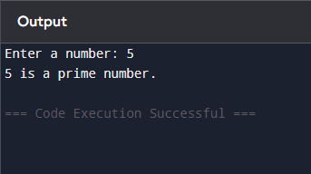

- Remove duplicates from a list

def remove_duplicates(lst):
return list(set(lst))

a = [1, 2, 3, 3, 2, 4, 5, 5]
print("Original list:", a)
print("Without duplicates:", remove_duplicates(a))

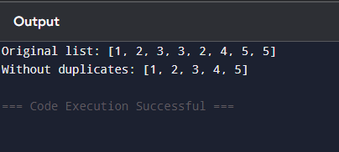

- Check if a number exists in an ordered list

def is_in_list(ordered_list, num):
return num in ordered_list

a = [1, 2, 3, 4, 5, 6, 7, 8, 9]
n = int(input("Enter a number: "))

print(is_in_list(a, n))

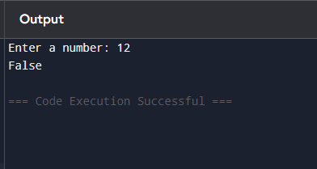

- Find the largest among three numbers (without using max())

def largest(a, b, c):
if a >= b and a >= c:
return a
elif b >= a and b >= c:
return b
else:
return c
x = int(input("Enter first number: "))
y = int(input("Enter second number: "))
z = int(input("Enter third number: "))

print("Largest number is:", largest(x, y, z))

